1. am setting the default value to the variable at the start of jmeter script.



2. then am changing this value in bean shelll sampler according to the user selected.



3. and using this changed value am trying to open another file.

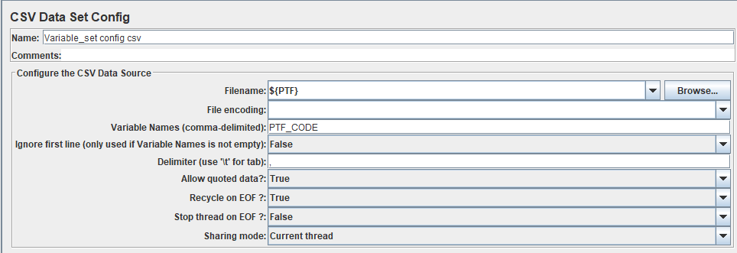

4. Its not able to open the corresponding file because parameter value used here is default one set initially.

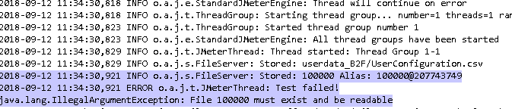

NOTE: The value is changed as seen in debug sampler, but not reflected.

5. It seems to be an issue in jmeter, can anyone help me fixing this.

Thanks in advance.